(E9.1) A system has the loop transfer function

$$L\left(s\right)=G_{c}\left(s\right)G\left(s\right)=\frac{2(1+s/10)}{s\left(1+5s\right)\left(1+s/9+s^{2}/81\right)}$$

Plot the Bode diagram. Show that the phase margin is approximately 17.5° and that the gain margin is approximately 26.2 dB.

Ans.

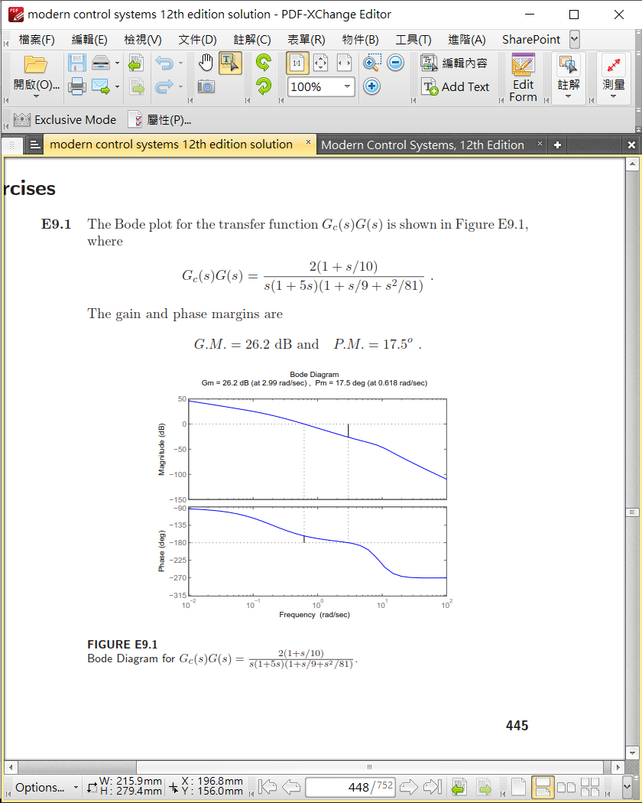

(P9.2) Sketch the Nyquist plots of the following loop transfer functions L(s) = Gc(s)G(s), and determine whether the system is stable by applying the Nyquist criterion:

$L\left(s\right)=G_{c}\left(s\right)G\left(s\right)=\frac{K}{s(s^{2}+s+6)}$

$L\left(s\right)=G_{c}\left(s\right)G\left(s\right)=\frac{K(s+1)}{s^{2}(s+6)}$

If the system is stable, find the maximum value for K by determining the point where the Nyquist plot crosses the w-axis.

Ans.

$G_{c}\left(jω\right)G\left(jω\right)=\frac{K}{jω(-ω^{2}+jω+6)}=\frac{K[-ω^{2}-jω(6-ω^{2})]}{[{\left(6-ω^{2}\right)}^{2}ω^{2}+ω^{4}]}$

* To determine the real axis crossing, we let

$Im\left\{G_{c}\left(jω\right)G\left(jω\right)\right\}=0=-Kω(6-ω^{2})$ or $ω=\sqrt{6}$

* Then, $Re{\left\{G_{c}\left(jω\right)G\left(jω\right)\right\}}_{ω=\sqrt{6}}=-\frac{Kω^{2}}{ω^{4}}{\left.​\right|}_{ω=\sqrt{6}}=-\frac{K}{6}$
* So, -K/6 > -1 for stability. Thus K < 6 for a stable system.
$G_{c}\left(jω\right)G\left(jω\right)=\frac{K(jω+1)}{-ω^{2}(jω+6)}$

* The polar plot never encircles the -1 point, so the system is stable for all gains K (See Figure 10 in Table 9.6 in Dorf & Bishop).

(P9.4) The Nyquist plot of a conditionally stable system is shown in Figure P9.4 for a specific gain K.

1. Determine whether the system is stable and find the number of roots (if any) in the right-hand s-plane. The system has no poles of Gc(s)G(s) in the right half-plane.
2. Determine whether the system is stable if the -1 point lies at the dot on the axis.

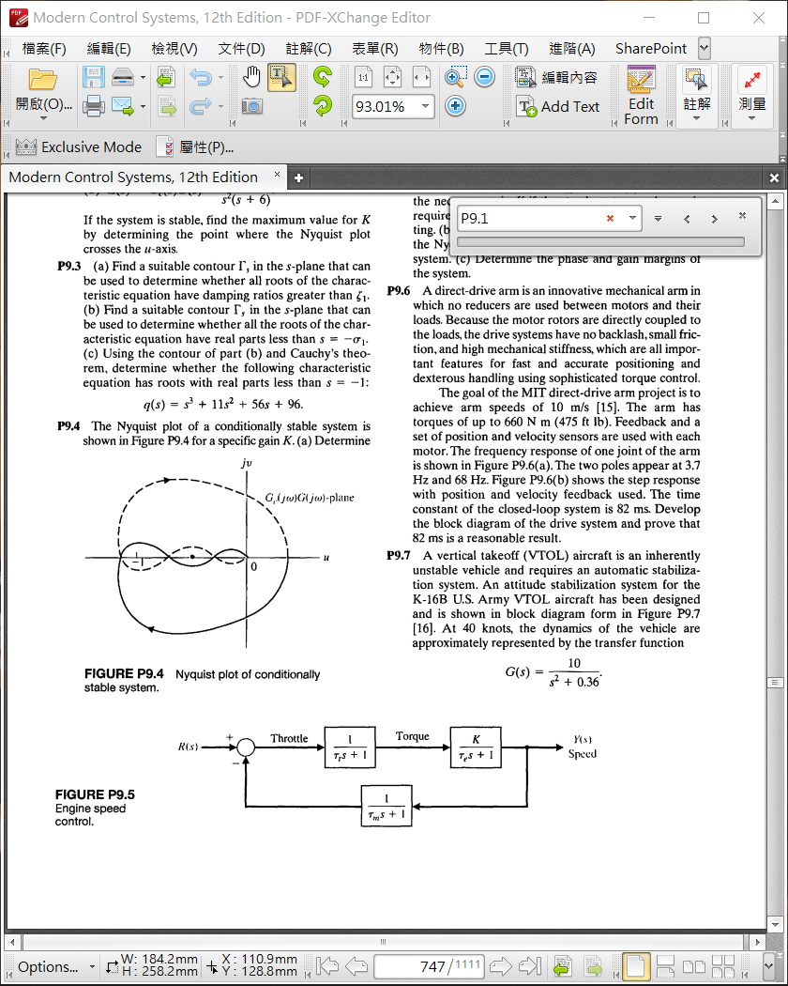

Ans.

1. P = 0, N = 2, therefore Z = 2. The system has two roots in the right-hand s-plane.
2. In this case, N = +1 − 1 = 0, so Z = 0. Therefore, the system is stable.